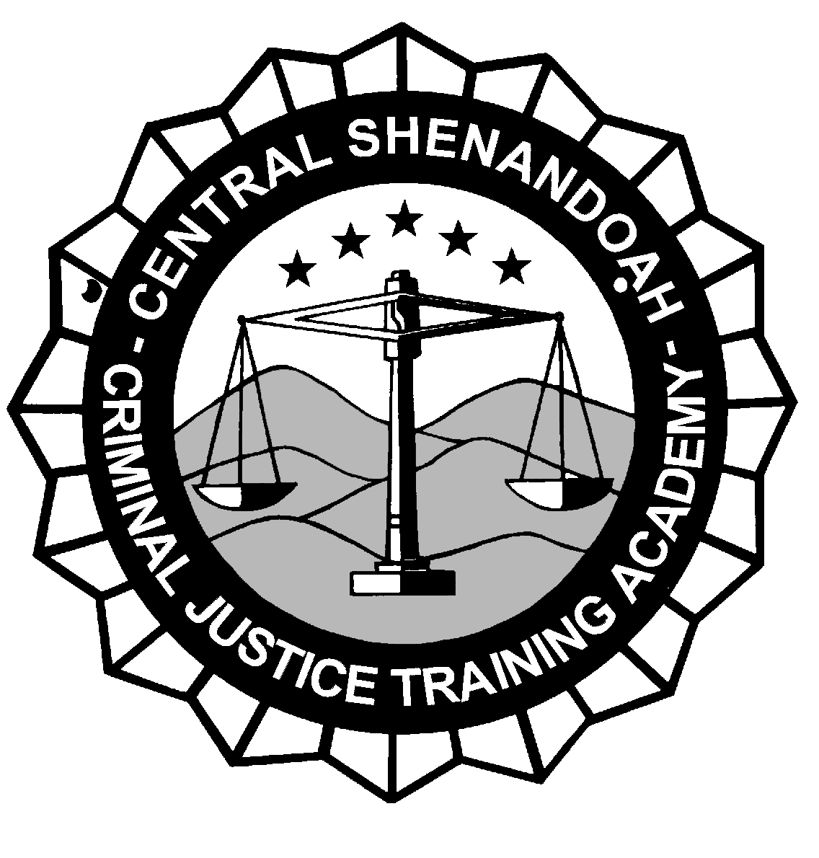CENTRAL SHENANDOAH CRIMINAL JUSTICE
TRAINING ACADEMY

Participant Registration Form
Individuals wishing to enroll in training programs at the Central Shenandoah Criminal Justice Academy shall complete this form and forward to the Academy Registrar at least ten (10) days prior to the beginning of the training program. Upon receipt of the training registration form, the Academy registrar will notify each participant to confirm registration. In the event a participant cannot attend the requested program, it will be his/her responsibility to notify the Academy to withdraw from the program.
The academy dress code for in-service and specialty training shall be business casual or department uniform. Blue jeans or shorts are not permitted, shirts MUST have a collar (no T-shirts) and flip flops or tennis shoes are NOT permitted. Students not in conformance with the dress code will not be admitted into training class.
Applicant’s Name/Rank:
 |  |  |  |  |  | (Last) |  |  |  | (First) |  |  | (M.I.)
Applicant’s SS#: |  |  |  |  |  |  |  |  |  |  |  | ( for DCJS tracking only )
Course Title:

Course Date(s):

Employing Agency:
Telephone Number of Applicant:
Email address:
As agency administrator or agency designee, I approve the registration of the applicant for this training program.
(Print) Name of Agency Administrator or Designee
Signature of Agency Administrator or Designee: |  |  |  |  |  |  |  |  |  |  | (Date)
Request for Dormitory Accommodations:
[ ] Yes [ ] No [ ] Male [ ] Female
Fax, mail, or e-mail to: Central Shenandoah Criminal Justice Training Academy

3045 Lee Highway
Weyers Cave, VA 24486
Attn: Kenzie Cooper, Registrar and Records Specialist
Fax # (540) 234-8211 E-mail: kcooper@cscjta.org
SECURITY AWARENESS: The Academy reserves the right to request and validate student employment credentials. All students attending must have photo ID available upon request.

ADM 126B Revised 9/22/2020

